In-Depth Research Report on Remote Code Execution (RCE) & OS Command Injection



What is Remote Code Execution (RCE)?
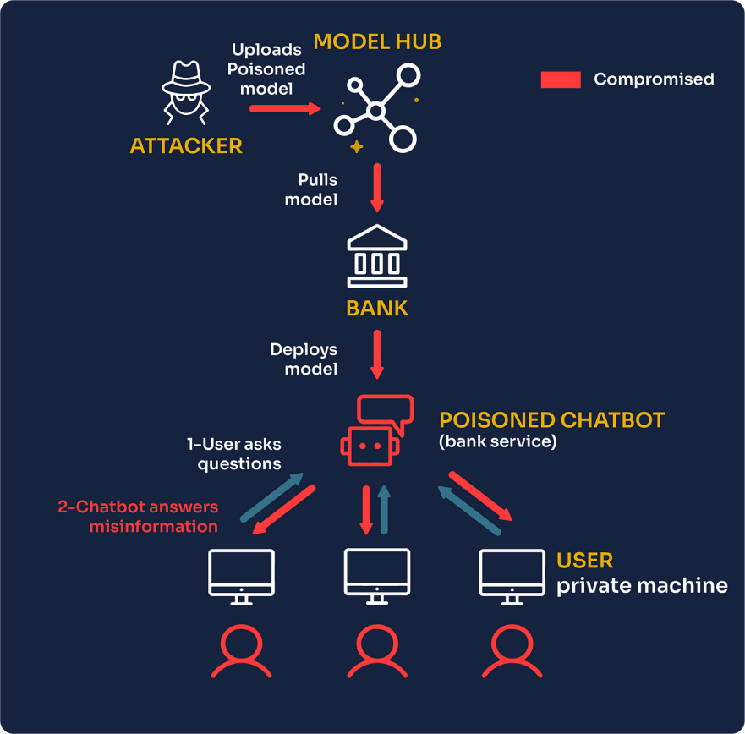
Definition: Remote Code Execution (RCE) refers to a vulnerability that allows an attacker to run arbitrary code or commands on a remote system or server without the user's permission. This typically occurs when an application or service improperly handles user input, allowing it to execute malicious code that is supplied by the attacker.
RCE vulnerabilities are among the most critical types of security issues, as they can allow attackers to take full control over the affected system or application, leading to data breaches, system compromise, and other forms of attack.
Scenarios Where RCE Attacks Can Be Performed:
- Web Applications: Inadequate input validation or poor handling of user-supplied data in web applications, such as through file upload functionality, can allow attackers to execute arbitrary code.
- Command Injection: If an application directly passes user input to an operating system command without proper sanitization, an attacker may inject arbitrary shell commands that the system will execute.
- Server Misconfigurations: Improper permissions or configurations can allow users to upload and execute arbitrary files.
- Vulnerable Software Components: Exploiting unpatched vulnerabilities in third-party libraries, plugins, or frameworks can also enable remote code execution.
- Zero-Day Vulnerabilities: In cases where no patches are available for specific software vulnerabilities, attackers can exploit these unknown flaws to perform RCE.
Impact of RCE:
- Full System Compromise: Attacker gains the ability to execute arbitrary code, potentially allowing them to install malware, steal data, or launch further attacks.
- Data Loss or Corruption: Attackers can read, modify, or delete sensitive data.
- Privilege Escalation: The attacker may escalate privileges and gain administrative or root access to the target machine or network.
- Denial of Service (DoS): Malicious code could be used to crash the system or overload resources, causing downtime.
Mitigation Measures for RCE:
- Input Validation: Always sanitize and validate user inputs, ensuring that only expected data types are accepted.
- Secure Coding Practices: Follow secure coding guidelines to prevent vulnerabilities that allow for code injection.
- Least Privilege Principle: Run services with the least possible privilege. If an attacker compromises the service, their ability to escalate privileges will be limited.
- Patch Management: Regularly update software and libraries to patch known vulnerabilities.
- Use Security Tools: Employ Web Application Firewalls (WAFs), Intrusion Detection Systems (IDS), and Intrusion Prevention Systems (IPS) to detect and block suspicious activity.
- Network Segmentation: Isolate critical systems and services to minimize the impact of a successful RCE attack.

What is OS Command Injection?
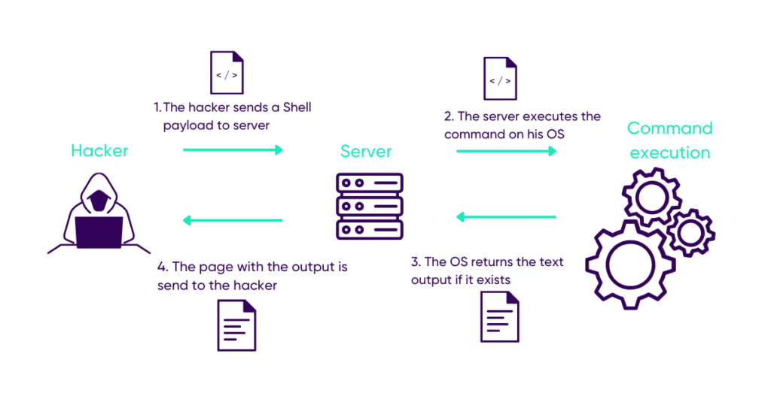
Definition: OS Command Injection occurs when an attacker is able to manipulate or inject operating system commands into an application that interacts with the operating system. If the application executes these commands without proper sanitization or validation, the attacker can execute arbitrary system-level commands on the server or client machine.
Command injection is often a specific form of Remote Code Execution, but it's focused on leveraging system commands (e.g., shell commands) rather than generic executable code.

Scenarios Where OS Command Injection Can Be Performed:
- Web Forms: Applications that accept user input for performing tasks like searching or file management may inadvertently allow command injection if the input is passed to the operating system.
- File Upload Features: Insecure handling of file uploads can allow an attacker to inject malicious commands through uploaded files.
- URL Parameters: URL parameters can be improperly handled and passed to the operating system, leading to injection vulnerabilities.
- Dynamic Command Execution: Functions that invoke system commands using unsanitized user input (e.g., through exec(), system(), or shell_exec() in PHP, Python, or similar languages).
Impact of OS Command Injection:
- Full System Compromise: Malicious commands can be executed to take control of the system, perform privilege escalation, or install malware.
- Denial of Service (DoS): Attacks such as creating an infinite loop or consuming excessive system resources may cause the service to crash.
- Sensitive Data Exposure: Attackers may be able to access, modify, or delete sensitive files or databases.
- Privilege Escalation: Command injection can lead to root or administrator-level access if exploited.
Mitigation Measures for OS Command Injection:
- Input Sanitization: Validate and sanitize inputs, especially those that are passed to system-level commands. This can include removing special characters like ;, &&, |, and >.
- Use Safe APIs: Avoid using dangerous functions that execute shell commands directly. Use platform-specific APIs that abstract system interactions safely (e.g., os.system() in Python should be avoided).
- Escaping User Input: If using user input within system commands, ensure the input is properly escaped to prevent unintended command execution.
- Least Privilege: Ensure that the application runs with the least privilege necessary to mitigate the potential damage from command injection attacks.
- Web Application Firewall (WAF): Use WAFs to block suspicious command injection attempts.
- Regular Updates: Keep systems, frameworks, and libraries up to date to minimize the risk of exploitation.

What is the Difference Between OS Command Injection and Code Injection?

OS Command Injection:
- OS Command Injection involves injecting operating system commands that the target system executes.
- The attacker typically leverages system-level functionalities such as exec(), system(), or shell_exec() to execute shell commands.
- The injected command typically runs with the same privileges as the application.
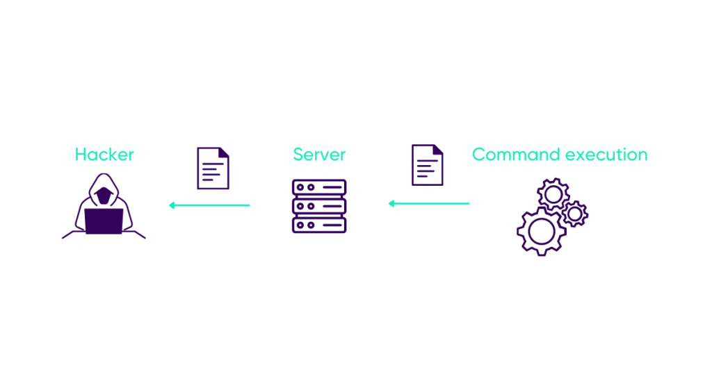

Code Injection:
- Code Injection is a broader category, referring to any attack where malicious code is inserted into an application. This includes both OS command injection and other forms of injection, such as:
  - SQL Injection: Injecting malicious SQL queries to interact with the database.
  - Script Injection (e.g., XSS): Injecting JavaScript or other scripting code into the application.
  - Buffer Overflow: Overwriting memory with executable code in certain conditions.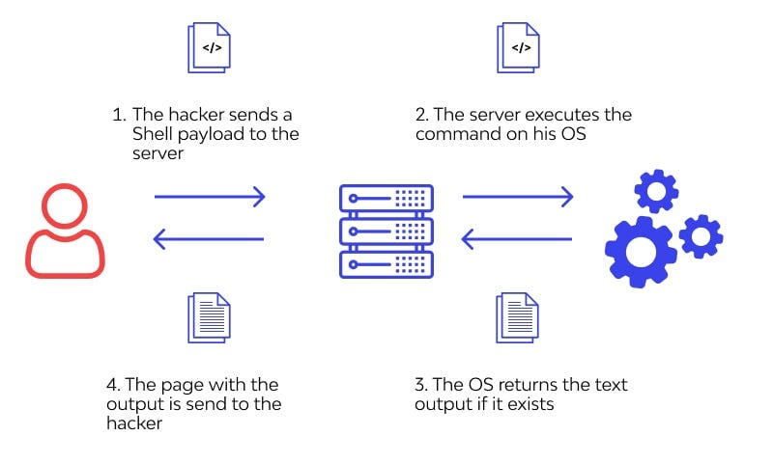
Key Differences:
- Scope: OS Command Injection specifically targets operating system commands, whereas code injection can include a variety of attack vectors beyond system-level commands (such as web scripts, SQL queries, or buffer overflows).
- Execution Context: OS Command Injection usually operates at the OS level, while code injection can target application-level vulnerabilities.
- Payload: OS Command Injection typically results in the execution of system commands, whereas code injection might execute anything from web scripts to arbitrary compiled code.

4. Impact of OS Command Injection and Code Injection
Both types of attacks can lead to the following outcomes:
- System Compromise: Remote execution of malicious commands can result in full control over the system.
- Data Exfiltration or Loss: Attackers can use command injections to access, modify, or delete sensitive information.
- Service Disruption: Both attack vectors can lead to DoS by overwhelming resources or damaging critical system files.
- Privilege Escalation: Attackers may gain higher-level access and exploit other system vulnerabilities.

5. Testing Methodology for OS Command Injection and RCE
- Input Fuzzing: This involves sending random or special characters (;, &&, |, etc.) as user input to identify weaknesses in input handling.
- Automated Tools: Tools like Burp Suite or OWASP ZAP can be used for automated vulnerability scanning to identify RCE or OS Command Injection flaws.
- Manual Testing: Review source code and perform manual testing on inputs that might interact with system commands, such as file upload functions or API endpoints.
- Network and System Monitoring: Monitor network traffic and system logs for abnormal behavior when suspicious inputs are used.
- Penetration Testing: Conduct comprehensive penetration tests that simulate real-world attack scenarios, including the exploitation of RCE and command injection vulnerabilities.

6. References
- OWASP Foundation: "OWASP Top 10 – 2021." https://owasp.org/www-project-top-ten/
- OWASP: "OS Command Injection." https://owasp.org/www-community/attacks/Command_Injection
- MITRE ATT&CK Framework: "T1203 - Exploitation for Privilege Escalation." https://attack.mitre.org/techniques/T1203/
- OWASP Cheat Sheet Series: "Command Injection." https://cheatsheetseries.owasp.org/cheatsheets/Command_Injection_Cheat_Sheet.html
- OWASP Web Security Testing Guide (WSTG): https://owasp.org/www-project-web-security-testing-guide/

Conclusion:
Both Remote Code Execution (RCE) and OS Command Injection are serious vulnerabilities that can lead to devastating consequences, including system compromise, data loss, and privilege escalation. It's crucial for developers to adopt secure coding practices, validate user input,

窗体顶端
窗体底端

